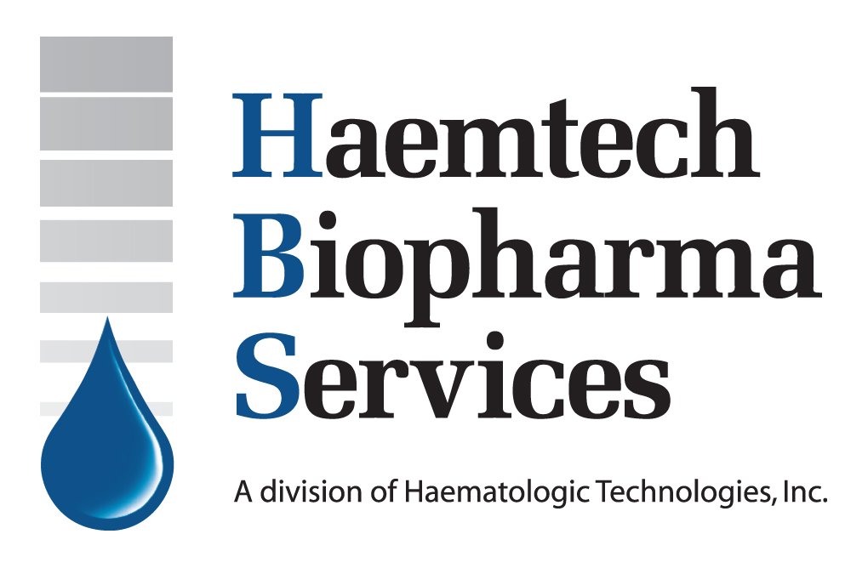

Subject: Company press release

Contact: Robert Myers, Director of Business & Marketing (rmyers@haemtech.net, 802-878-1778)

Date: Current PR Date, 2013

Release Date: Release at will

Haemtech Biopharma Services Validates first Thrombin Generation Assay for commercial ivIG product release

Current PR Date, 2013 -
Essex Junction, Vermont – Haemtech Biopharma Services (HBS) is pleased to announce the successful validation of a thrombin generation assay (TGA) for an IVIG drug. The assay was validated in 2012 to support the use of TGA as a release assay for Biotest Pharmaceuticals Corporation’s U.S. Food and Drug Administration Biologics License Application for BIVIGAM® [Immune Globulin Intravenous (Human), 10% Liquid] product. The validated TGA assay was designed and performed on the Calibrated Automated Thrombogram® platform (CAT) from Diagnostica Stago, Inc. (Parsippany, NJ).

What is the Thrombin Generation (TG) Assay (TGA)?
TGA is a universal test capable of assessing a research subject’s global hemostatic balance in the case of hemorrhage or thrombosis. The CAT method is both specific and sensitive, thus giving increased relevance to hemostatic testing in academic research centers, pharmaceutical companies and contract research organizations.

“We are very proud to have been able to assist Biotest Pharmaceuticals Corporation on their rigorous path to BIVIGAM® regulatory approval. BIVIGAM is the first newly FDA approved Immune Globulin product to utilize a CAT based TGA assay.” said Richard Jenny, HBS’s President and CEO. “There has been an increasing push by regulatory authorities for plasma-based biotherapeutics manufacturers to improve upon methods used to determine the thrombogenic potential of their products. We believe the validation of this assay to be a significant step toward our ability to help all manufacturers meet this goal. We can now use our experience to offer TGA assay development, validation and implementation services to all plasma-derived drug product manufacturers looking to satisfy regulatory requirements,” he added.

Using this specific and effective method coagulation factor XIa-like, procoagulant activity can be measured in IVIG and other plasma-derived therapeutics. In this way, the thrombogenic potential of these drugs can be measured and thus enable manufacturers to increase the safety of their drug product, and satisfy regulatory requirements on the road to product submission.

About Haemtech Biopharma Services (HBS)

Haemtech Biopharma Services is a provider of cGMP contract services for the biotherapeutics industry. Services provided include the development, validation and implementation of TGA and anti-drug antibody (ADA) assays as well as stability and release testing for biotherapeutics. You may visit them on the web at www.haemtechbiopharma.com.

About Diagnostica Stago, Inc.

Diagnostica Stago, Inc. is the exclusive provider of the Diagnostica Stago Hemostasis product lines in the United States and offers a complete system of coagulation instruments and optimized reagent kits for research as well as for routine analysis. Diagnostica Stago, Inc. is the U.S. subsidiary of Diagnostica Stago, S.A.S. France, a leader in the development and manufacture of Hemostasis products. For more information about any Stago product or service, please call 800-222-COAG or visit our website at www.stago-us.com.

About BIVIGAM®

BIVIGAM® [Immune Globulin Intravenous (Human), 10% Liquid] utilizes a non-sugar-stabilizer – Glycine. BIVIGAM is available in 50 mL and 100 mL tamper evident vials. For more information please visit www.BIVIGAM.com.

About Biotest Pharmaceuticals Corporation

Biotest Pharmaceuticals Corporation was created as a wholly-owned US subsidiary of Biotest AG in December 2007. Innovative technologies and a sharp focus on safety are incorporated into every facet of the business. From plasma collection to product
manufacturing and distribution. Biotest Pharmaceuticals Corporation is committed to maintaining high standards of excellence. Please visit www.Biotestpharma.com.

###

